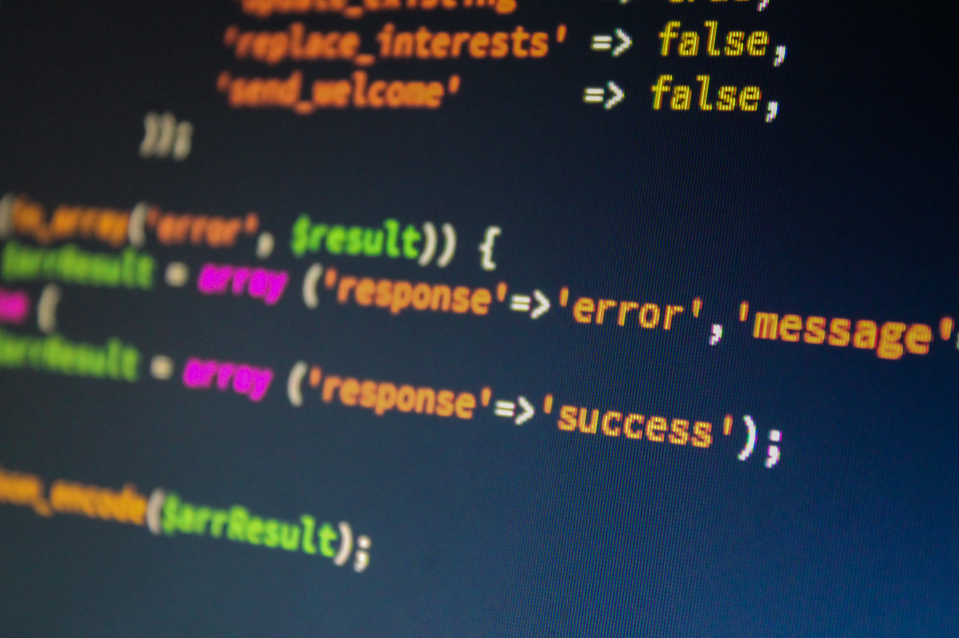**MEDICAL INVENTORY SYSTEM USING**

**PYTHON**

**SUBMITTED TO** : **POOJA RANA MAM**

**SCHOOL OF COMPUTER SCIENCE, LOVELY PROFESSIONAL UNIVERSITY PHAGWARA, PUNJAB**

#### Submitted By:

**SOUMYAKANTI SAHU**

**REG: 11901646, ROLL:16**

**SHASHANK KUMAR UPADHYAY**

**REG:12013040, ROLL:73**

MEDICAL INVENTORY SYSTEM

-Made by Soumyakanti Sahu,Shashank

Inventory Management has a vital role in the Healthcare Industry, especially when people’s lives are at stake. The Inventory Management Software lets you know the detail information on medicines batches & stock. It is also very useful in maintaining the doctor’s equipment.

Overall, it takes care of your inventory, purchases, sales orders, payments, etc. It protects your company from potential damage. Inventory management is important for every business type whether a medical company or any medical store.

With the help of **Inventory Management software,** any hospital or medical store can keep precise and updated stock records. Especially for pharmaceuticals and surgical equipment. It is one of the most significant jobs for any hospital organization.

This Project is a basically a small prototype of medical inventory software that are Present in the Medical Organizations.

In this project we used GUI. We used the module **tkinter** to make the GUI based functionality in this project

In our project we worked on few main aspects/requirements of these medical organization.

CODE FOR OUR SOFTWARE IS AT THE FOLLOWING LINK:

<https://onlinegdb.com/SJlHcrzjdv>

OUR OUTPUT SCRREN OF OUR CODE LOOKS SOMETHING LIKE THIS:

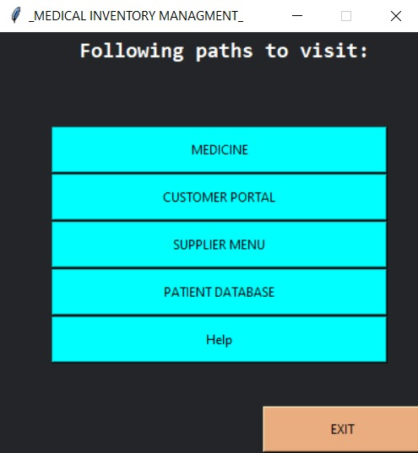

WHAT IS THE CODE ALL ABOUT:

The code is available at:

<https://onlinegdb.com/SJlHcrzjdv>

Firtsly, we import Tkinter, **Tkinter** is the standard GUI library for **Python**. **Python** when combined with **Tkinter** provides a fast and easy way to create GUI applications. **Tkinter** provides a powerful object-oriented interface to the **Tk** GUI toolkit.

In our code we mainly used functions to work all around the project…we firstly defined a main function in which we made a gui window(that is the window which is shown in the picture) In the gui window we created labels and different buttons with there different functionality..using the command function in the buttons we difened different funtionalty to those buutons

Taking an example:

In the first output screen there are many options coming in the screen i.e MEDICINE< CUSOMERS,etc… suppose we chose medicine,,, so in the medicine button we used command function and defined functionality of that medicine button …..we named the functionality or function as B1fun( IN MEDICINE button)…in that function we defined one other window of gui in which some more functionalit yare present ….one of them is add new medicine ….for this we needed an csv fie to be linked to that button of add new medicine so we added an function as csv file.